附件2：第五期教师英语应用能力提升培训班课程安排表
Week | Day/Time | Contents | Teacher
1st week | 18:00-18:30 | Opening Ceremony
1st week | 18:30-20:30 (3 sections)  09/05/2019 - Thursday | Communication English Skills (Greetings)(Airport)  Interacting Practice Session (Greetings)(Airport) | Dr. Karim
1st week | 18:30-20:30 (3 sections)  10/05/2019 - Friday | Introduction to Teaching of Medical Professionalism  Medical Pronunciations & Medical Terminology (I) | Dr. Karim
2nd week | 18:30-20:30 (3 sections)  16/05/2019 - Thursday | Communication English Skills (Hotel)(Restaurant)  Interacting Practice Session (Hotel)(Restaurant) | Dr. Karim
2nd week | 18:30-20:30 (3 sections)  17/05/2019 - Friday | Medical Pronunciations & Medical Terminology (II) | Dr. Karim
3rd week | 18:30-20:30 (3 sections)  21/05/2019 - Tuesday | Communication English Skills (Talking to Strangers)  Interacting Practice Session (Talking to Strangers) | Dr. Karim
3rd week | 18:30-20:30 (3 sections)  22/05/2019 -Wednesday | Departments & Its Common Diseases  Sharing Experiences, Ideas & Discussion Techniques | Dr. Karim
4th week | 18:30-20:30 (3 sections)  30/05/2019 - Thursday | Basic Writing Rules in English & Writing Techniques  *Oral Test (Interactive Practice Test) | Dr. Karim
4th week | 18:30-20:30 (3 sections)  31/05/2019 - Friday | Standard English PPT Design & Presenting Techniques;  *Written Test (Multiple Choice Questions) | Dr. Karim
5.8-5.31 | 自学网络培训课程:  1.《医学院校英语教学能力提升》  2.《英语语言》 | 选课及学习方法：  - 登录湖北医药学院教师在线学习中心，网站：http://online.enetedu.com/hbmu/Index/Index  - 注册：姓名、学校、部门（院系）等必须要填写真实信息，院系要填写所在学院，不能填写XX医院；  - 选择“在线点播课程”-“专业课教学培训”选中课程，点击“查看课程”-我要报名-提交  - 进入个人中心-我的在线课程-点击学习  - 学习截止时间:5月31日 | 联系人：马进  电话：  8891086  13597895079/6991
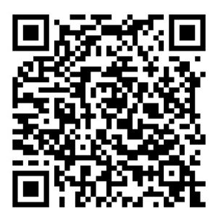
温馨提示：
参加培训教师扫描二维码加入班级：
班级名称：第五期教师英语培训班

